

**Lab No. 09**

Mehran University of Engineering and Technology Shaheed Zulfiquar Ali Bhutto Campus, Khairpur Mir’s Department of Software Engineering

**Course: Operating System SW-225 (Practical) - Instructor: Engr. Shamshad Naveed**

# Objective: Installing a Linux Environment/Setting up a Virtual Environment for Linux

|  |  |  |  |  |
| --- | --- | --- | --- | --- |
| **Name:** | **Muhammad Saleem** | **Roll Number:** | | **K20SW033** |
| **Score:** | **Signature:** | **Date:** | **14/10/2022** | |

|  |  |  |  |  |  |  |  |
| --- | --- | --- | --- | --- | --- | --- | --- |
| **LAB PERFORMANCE INDICATOR** | SUBJECT KNOWLEDGE | DATA ANALYSIS AND INTERPRETATION | ABILITY TO CONDUCT EXPERIMENT | PRESENTATION | CALCULATION AND CODING | OBSERVATION  /RESULTS | SCORE |
|  |  |  |  |  |  |  |  |

**Exercise:**

**Task:** Install linux operating system by setting virtual environment.

First, we will create a live ubuntu base live Linux USB for this we will follow following steps:

# Step 01:

Download Ubuntu by clicking the below link: <https://ubuntu.com/download/desktop>

# Step 02:

Download Linux Live USB Creator “Lili” by clicking the below link: <http://www.linuxliveusb.com/en/download>

# Step 03:

Now we will install “Lili” in our system, for this we will find our “Lili” setup and install in our system by right click of our mouse and click on “Run as Admintrator” and after that we will click on “Yes” and click on “Install”

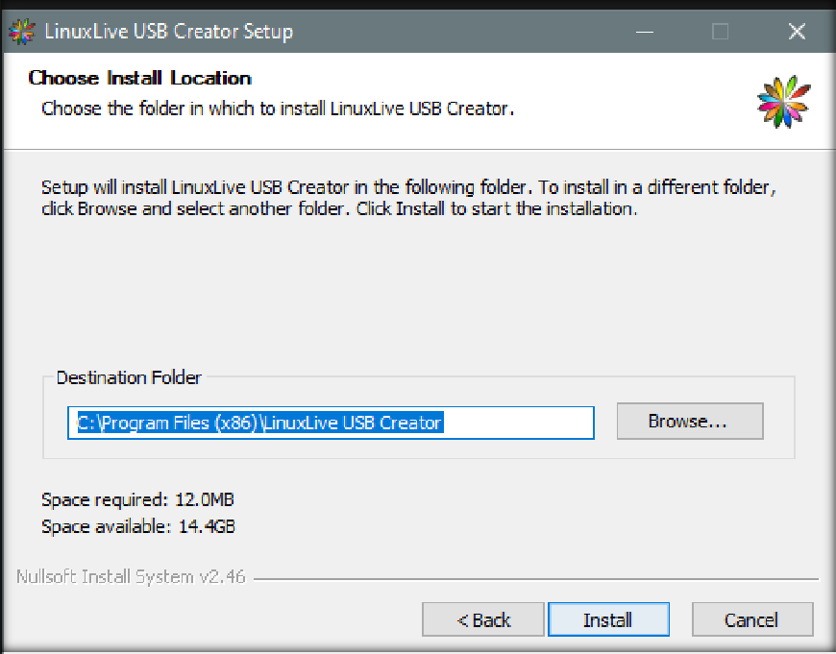

After that click on “Finish”

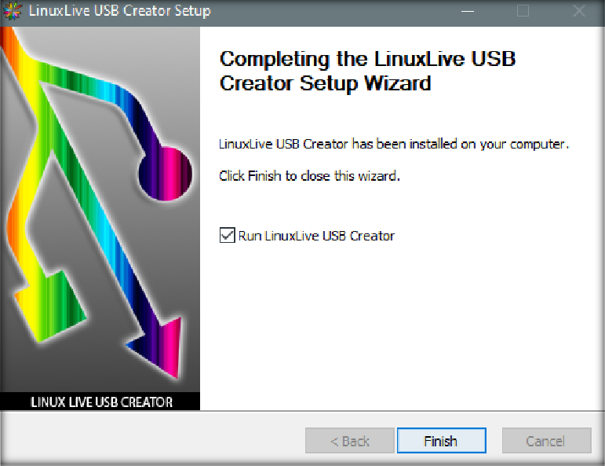

# Step 04:

Now make a Ubuntu base USB, by using following steps:

* Open the “Lili USB Creator”

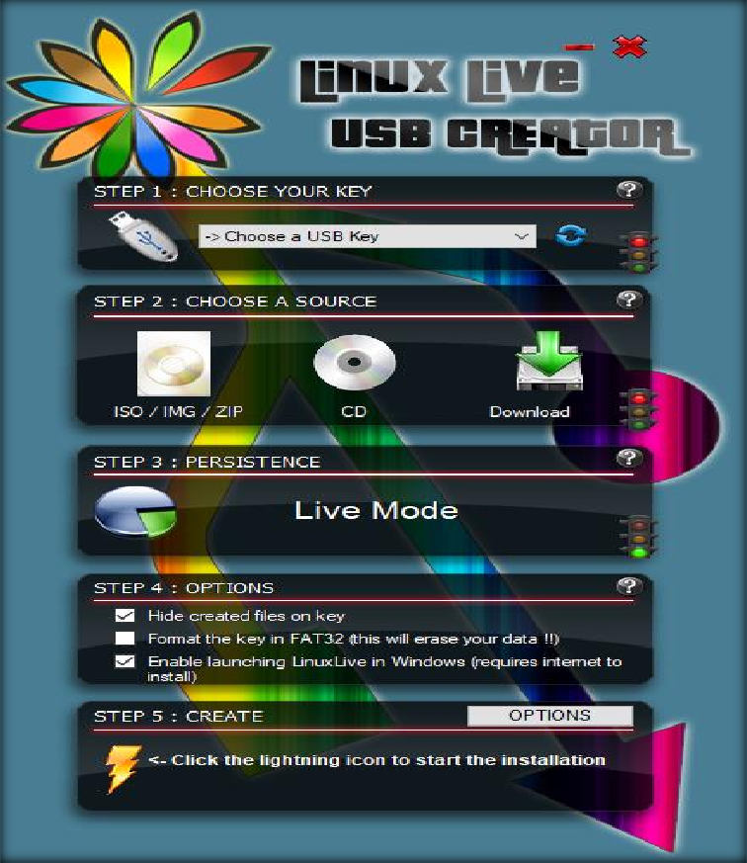

* Choose the USB Key and click on your “USB”

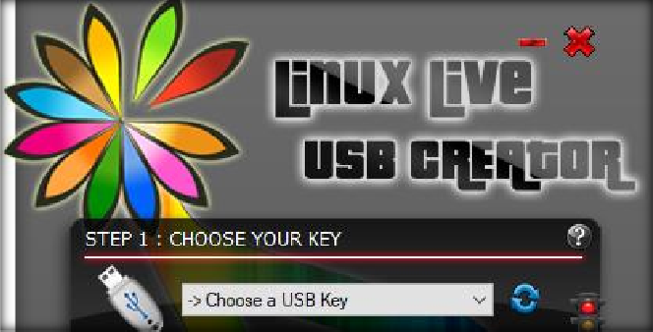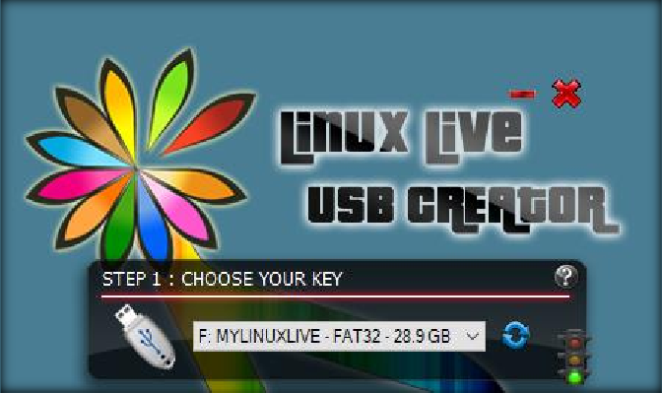

* Choose a source “USB”

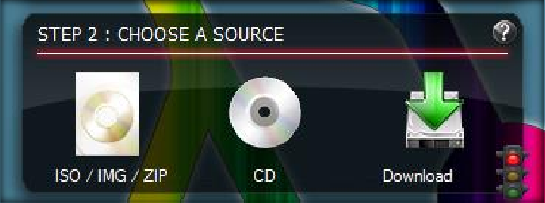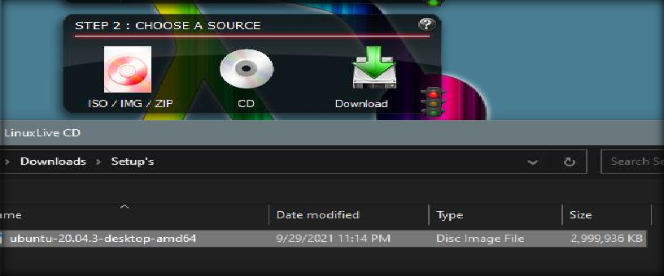

* Now enter the “Presistence” “4090”

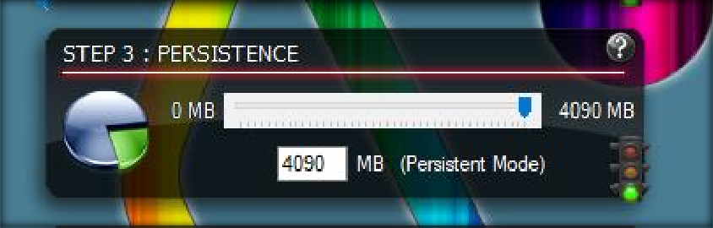

* Now check all 3 options

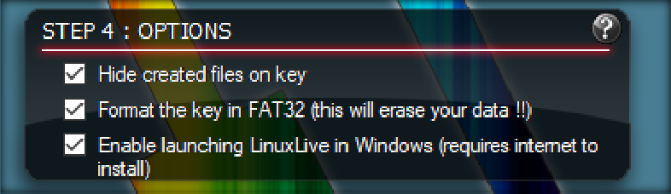

* Now click the lighiting icon

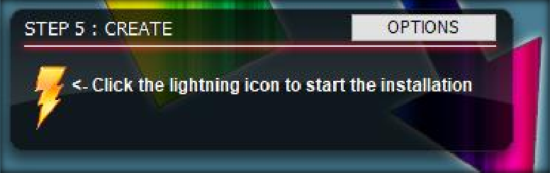

* Click on “OK”

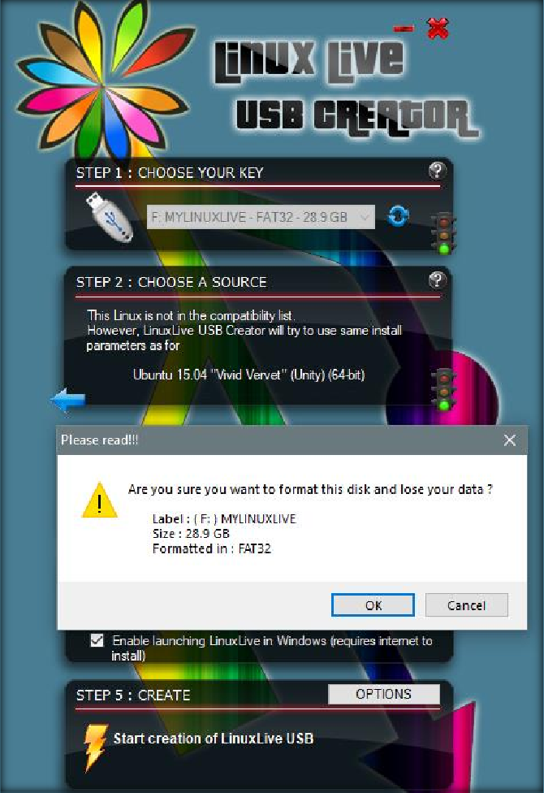

* Now the process gets started, it will take some time.
* Now the Live Linux USB is ready

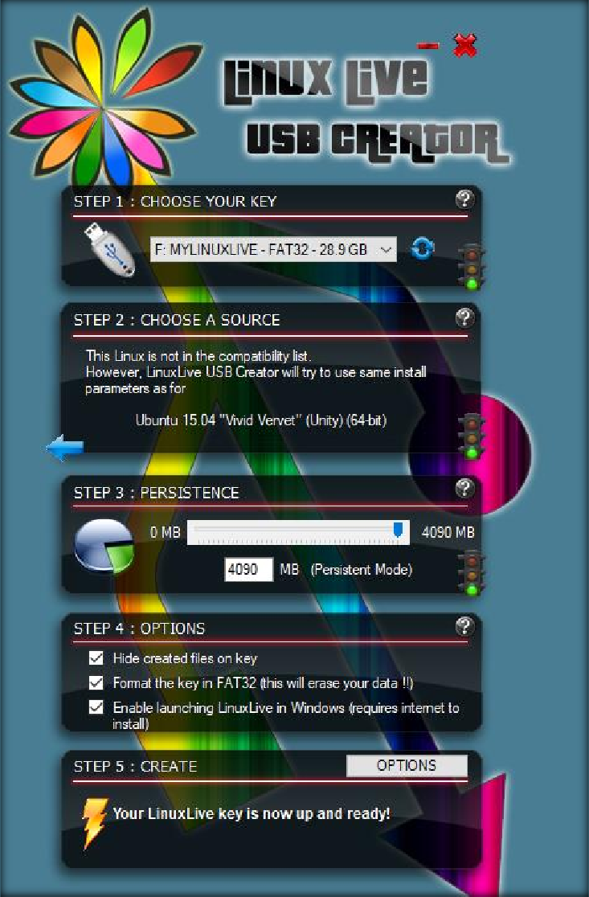

Now restart your PC and enter BIOS key, Linux will be started

# Step 05:

Now click on your “Live Linux” USB

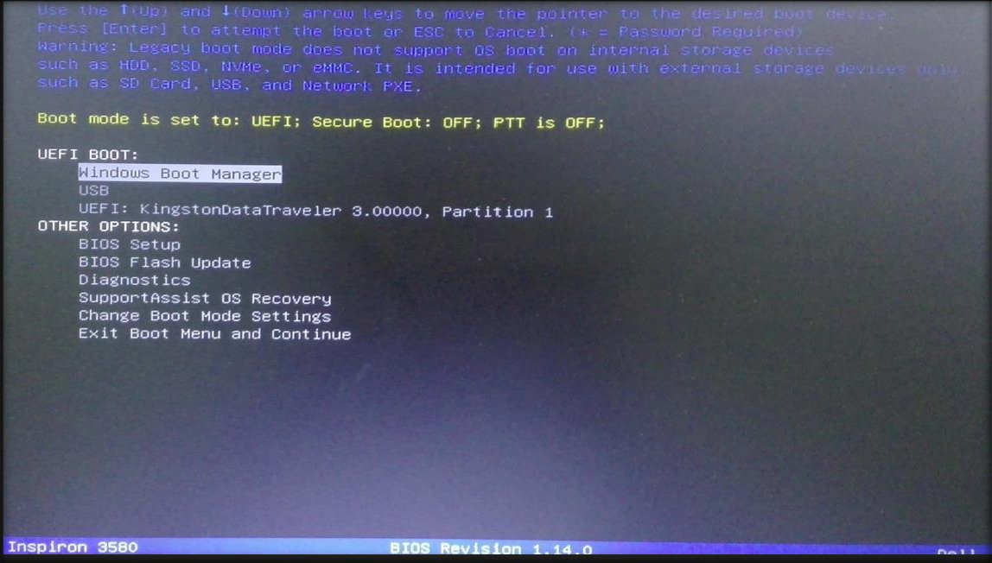

# Step 06:

Now click on second option

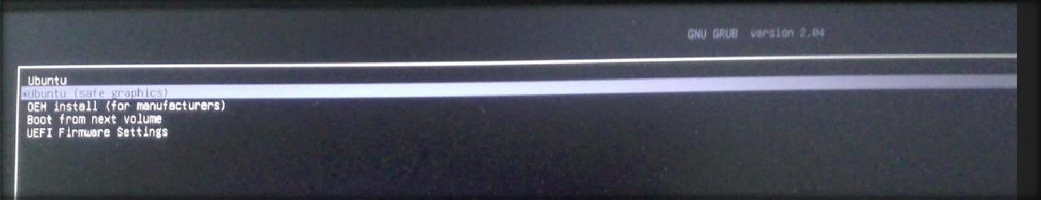

**Step 07:**

Process starts

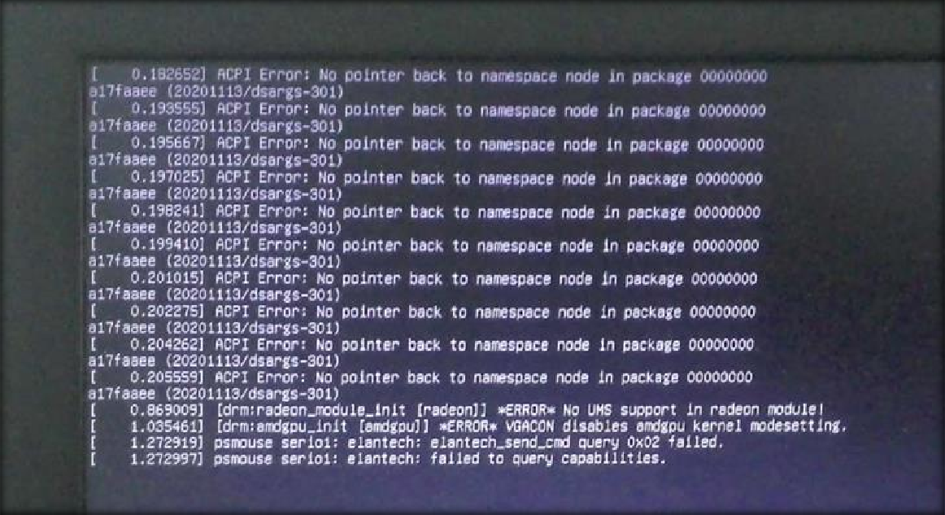

# Step 08:

Linux is getting started

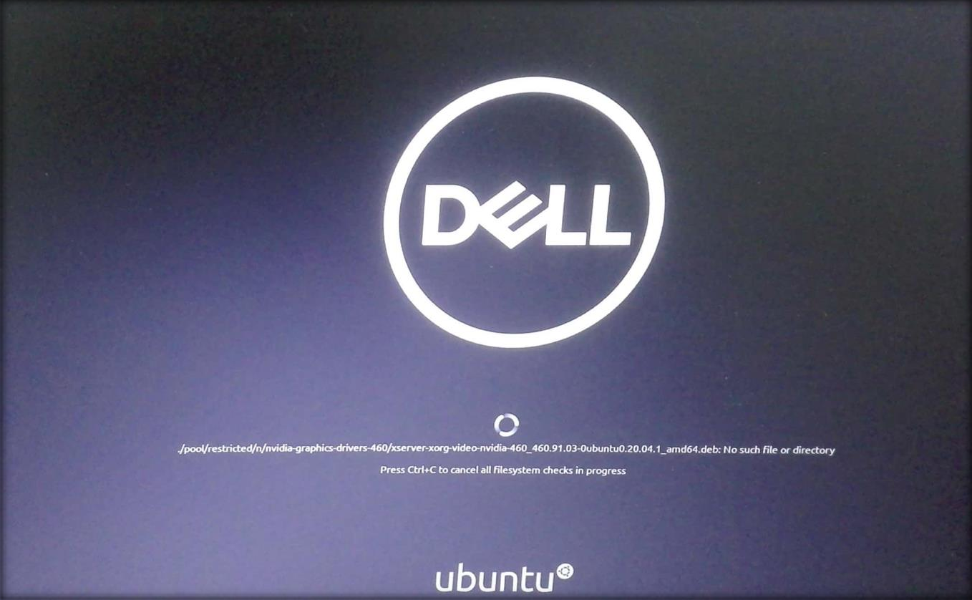

**Step 09:**

Select the “Try” option

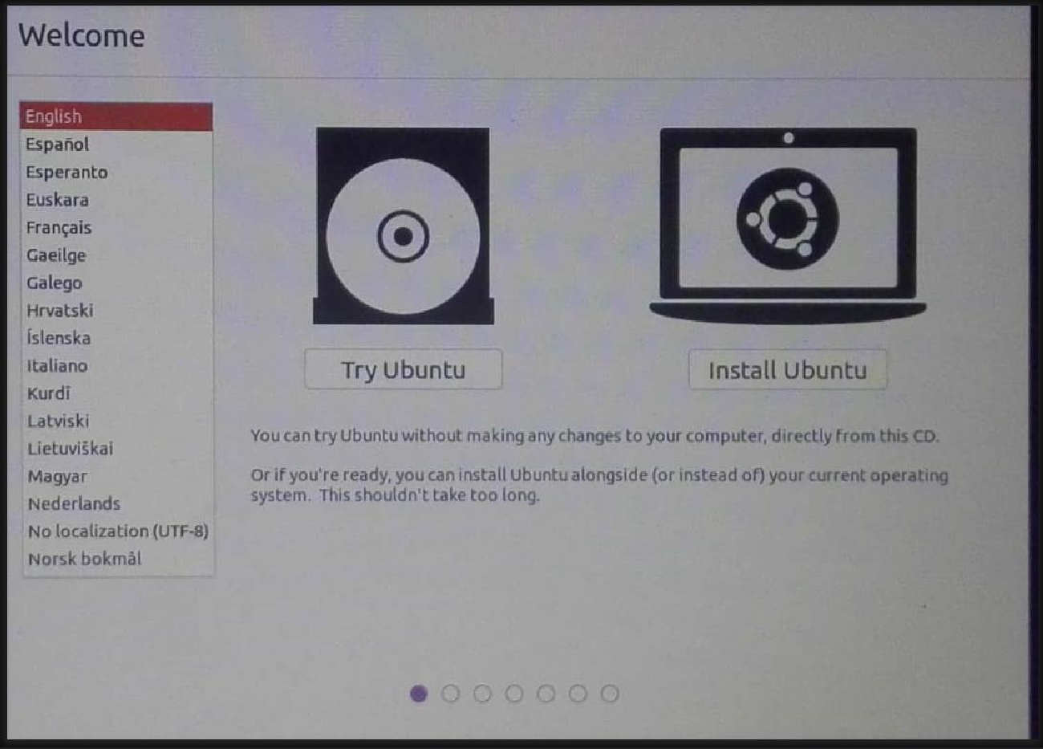

# Linux is now successfully installed, here is the main interface of Linux

